Chemistry 115 Name
Dr. Cary Willard
Quiz 2A (20 points) February 9, 2009

All work must be shown to receive credit.

- (5 points) Use dimensional analysis to determine the number of dimes that are equal to 45 quarters.

- (5 points) A tree is 65.3 feet tall. How tall is the tree in meters?

- (5 points) My dog has a mass of 35.4 kg. How many mg does my dog weigh?

- (5 points) The ruler below is calibrated to measure centimeters. How long is the line in cm?

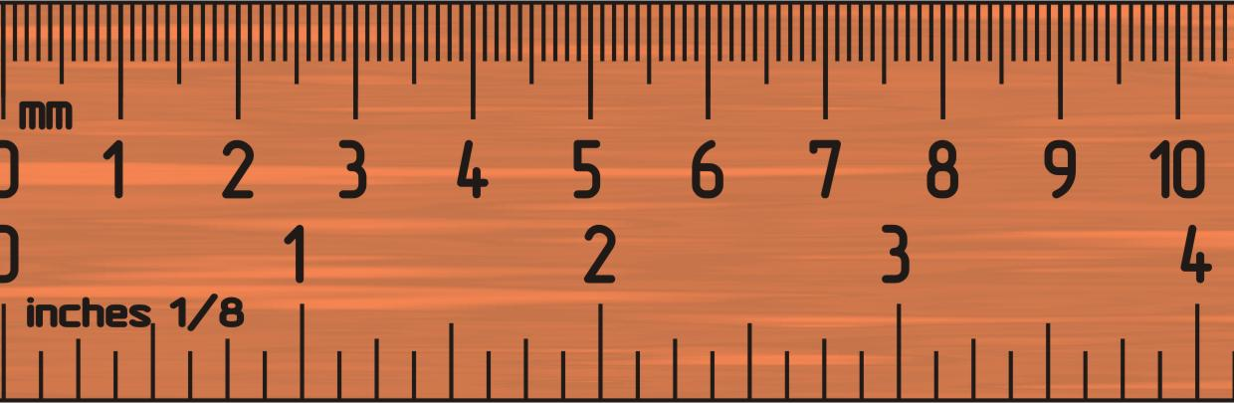
Chemistry 115 Name
Dr. Cary Willard
Quiz 2B (20 points) February 9, 2009

All work must be shown to receive credit.

- (5 points) Use dimensional analysis to determine the number of dimes that are equal to 65 quarters.

- (5 points) A tree is 52.8 feet tall. How tall is the tree in meters?

- (5 points) My dog has a mass of 26.4 kg. How many mg does my dog weigh?

- (5 points) The ruler below is calibrated to measure centimeters. How long is the line in cm?

